**TCClogo_color.wmf**

**Creating a requistion. Step by Step Process**

**Requistion Overview**

* Requisitions are completed and processed electronically in the Online Hiring Center (OHC) of NEOGOV.
* After a requisition has been created and routed through the approval process each Approver/HR will automatically receive an email generated from NEOGOV to notify them that a requistion has been created and their action is required.
* The Hiring Manager field on the requisiton is what determines who will be able to view the electronic applications in OHC.
  + Multiple Hiring Managers can be selected as well and all will have access to view the list of referred applicants.

**Routing a Requistion for Approval**

* Requisiton approval steps can be assigned to each requisiton based on the type of requisition your department is submittting.
* Each requistion can have unique approval/routing groups depending on the requisition.
* The fields marked with asterisks (\*) are required fields.

**Glossery**

**Department Approval Group –** Each level of requisition approval must have a

Requisition Group (Department Approval Group) defined

**Department User –** The following types of Requisition User roles are available

* **HR Liaison or Originator** –The representative from the requesting department/division who is responsible for creating the requisition.
* **Approver** –Any user who will be responsible to review/approve requisitions
* **SME (Subject Matter Expert)** – Any user who is assigned to review and rate applications as a subject matter expert
* **Hiring Manager –** The department/division hiring manager who will receive the list of referred applicants.
* **HR Analyst –** The HR Analyst automatically receives the requisition after all approval steps are complete.

**Getting Started:**

Go to [www.neogov.com](http://www.neogov.com). Click the login button on the top right.

|  |
| --- |
|  |



Enter your user name and password. ***Your*** ***user name is your TCC email address***, ie. [jjones@tacomacc.edu](mailto:jjones@tacomacc.edu). If you do not know your password or need a password reset call Paula 5096, Claire 5075, or Shelley 6024.

Click the Online Hiring Center button and click on login.

Requsitions are created only in the Online Hiring Center (OHC).

|  |
| --- |
|  |

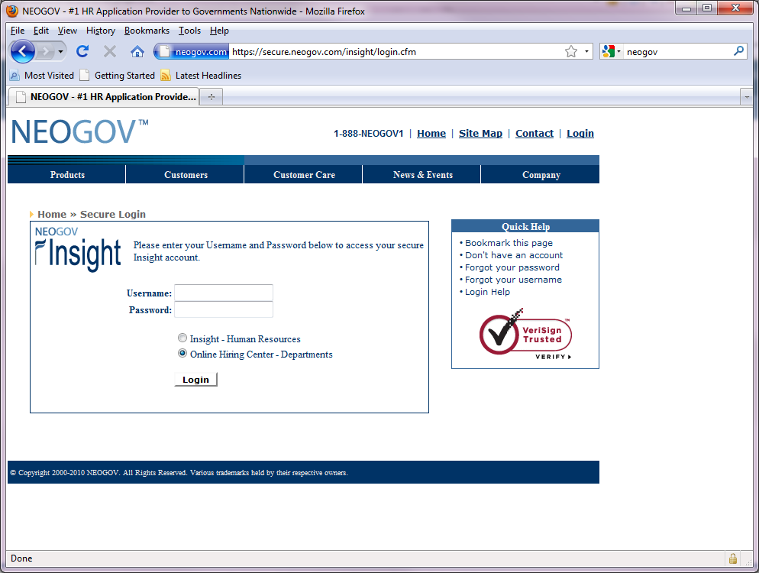

Click on Open New Requisition located on the top left.

|  |
| --- |
|  |

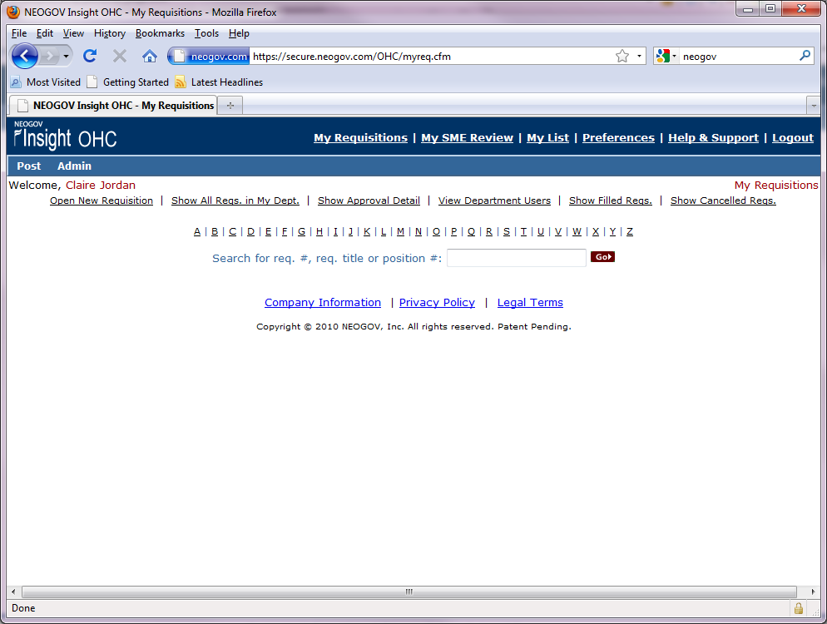

Select the Class Title of the requisition you wish to create.

**Note:** **If the title is not listed use “New Position” Class Title.**

**You will need to attach a position description along with the requisition. Human Resources will then add the new Class Title to the list. Contact Claire or Paula for more information. If your recruitment requires a recruitment plan or if your Vice President requires a memo of justification for the position, you may attach that as well.**

Click on Create New next to the corresponding class title for your requisition.

|  |
| --- |
|  |

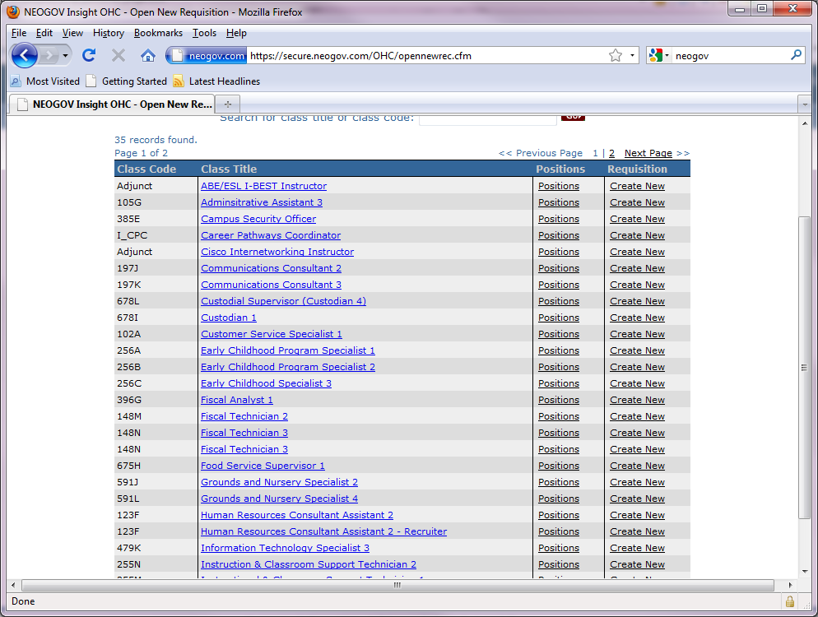

Complete the online requisition.

Select hiring managers (all those who will view and receive applicants)

**Note: Working Title = TCC Official Job Title**

Complete all boxes as applicable. Check with HR if you have any questions.

|  |
| --- |
|  |

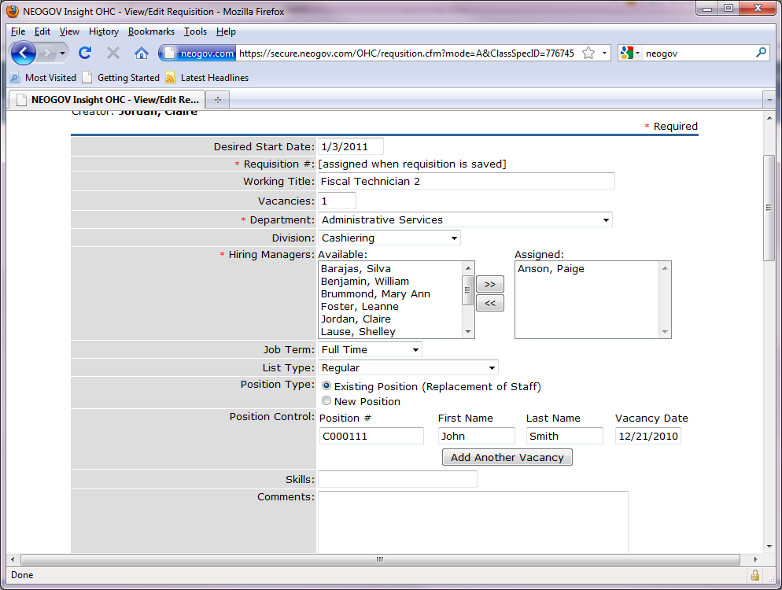

Hourly Individual Name(s): John Smith

J

J

If position type is an existing position mark the existing position box.

You must then select “Add Another Vacancy” in order to fill in the position #, First Name, Last Name, and Vacancy Date of the previous employee. If you do not know the position number, contact Claire, Paula or Agnieszka and they will provide that information to you.

Use the Comments box to list the names of those hourly individuals you have already hired.

Check with HR if you have any questions.

Continue filling out the requisition answering all the questions if applicable.

If requisition is for an hourly appointment an example is shown below.

|  |
| --- |
|  |

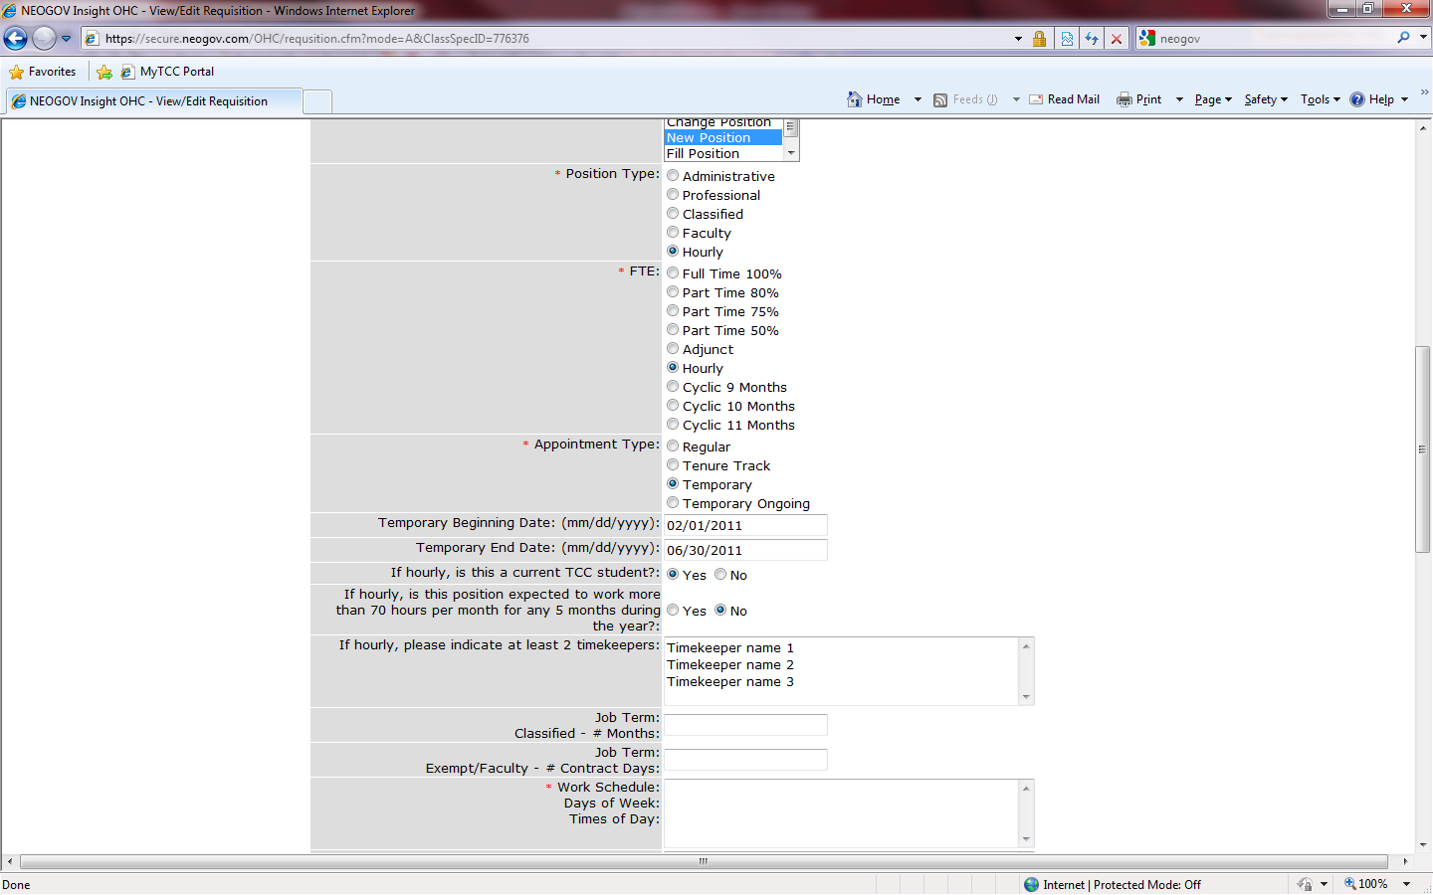

Select the proper approvers for the requisition from the Approval drop down menu.

See your Requisition Approval Cheat Sheet or call Claire or Paula if you have any questions.

Highlight name(s) of the approver for each approval group.

|  |
| --- |
|  |

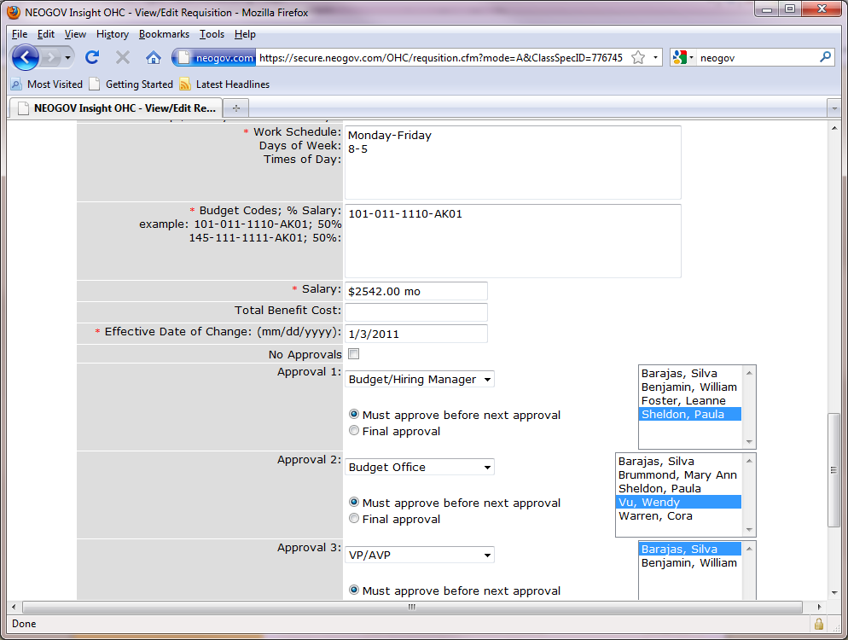

Please include the full budget number including the prefix. ***If you have questions about the budget code prefix, you can contact HR or the Budget Office.*** (Example 101-083-1830-AK-01)

The suffix is as follows.

AA = Executive

AC = Professional

AD = Exempt Temp

AE = Faculty

AG = Temp FT Faculty

AK = Classified

AD = Hourly

AM = Student

You may press Save only if you would like to come back to the requisition and make any changes before submitting it to the approvers.

Otherwise press the Save and Release button. Each approver will receive an email letting them know when their action is required.

Congratulations! You have created an online requisition.

|  |
| --- |
|  |

