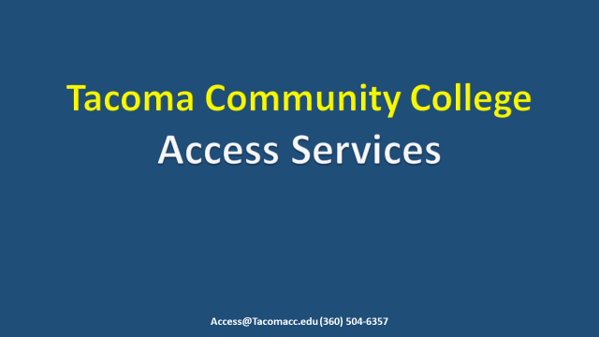
Welcome to Access Services at Tacoma Community College. Thank you for joining us for this tutorial. Here, steps will be provided to show you how to request your Approved Academic Accommodations by quarter.

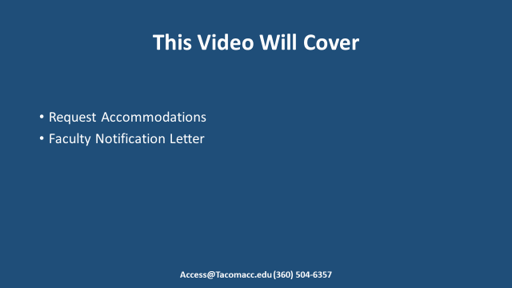
This video will cover how to request accommodations for individual Classes and where to find your Faculty Notification Letter.

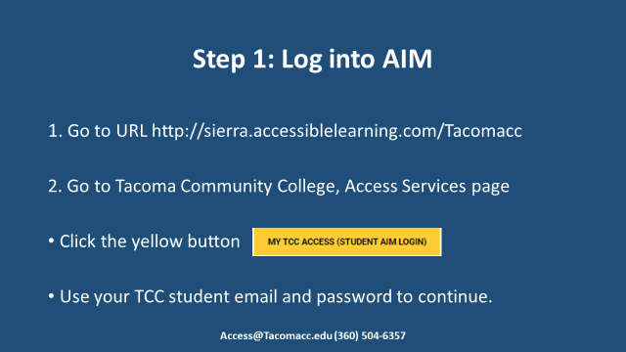
Step one; Log into AIM one of two ways. Navigate to URL https://sierra.accessiblelearning.com/Tacomacc OR Go to Tacoma Community College, Access Services page and click on the yellow button MY TCC ACCESS STUDENT AIM LOGIN. Either way you log in aim you will be required to use your TCC student email and password to continue.

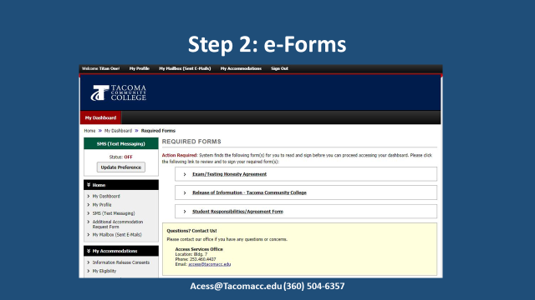
Depending on your approved accommodations, you will be asked to read and electronically sign e-Forms. Be sure to read these forms in their entirety. You will be prompted to sign the Rights and Responsibilities e-Form each year. Other forms need to be signed each quarter. Select one of the forms to sign. This will display the text for all required forms on the same page.
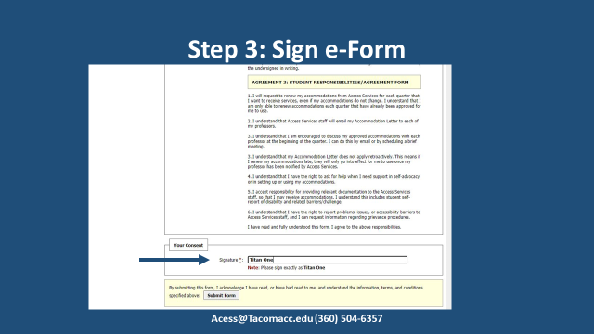
Please read the e-Form thoroughly. Sign the e-Form with your first and last name. Once you click on the submit form button you have agreed to the terms and conditions specified.

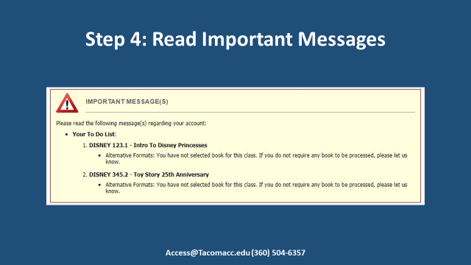
After you have logged into AIM you may see important messages displayed at the top of the page.

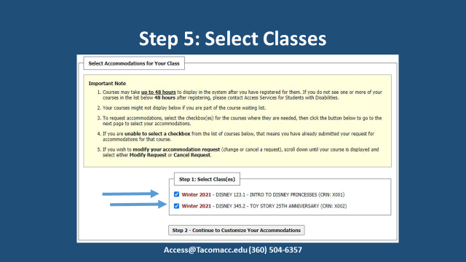
Below important messages is a section called “Select Accommodations for your Class.” The classes that you are registered for will be listed as shown. Check on the box to the left, for classes that you want to use accommodations for. If you registered, and do not see your classes listed, please wait 48 business hours and check back to see that the classes are now listed. After you have selected the classes click on the button Continue Customizing Your Accommodations.

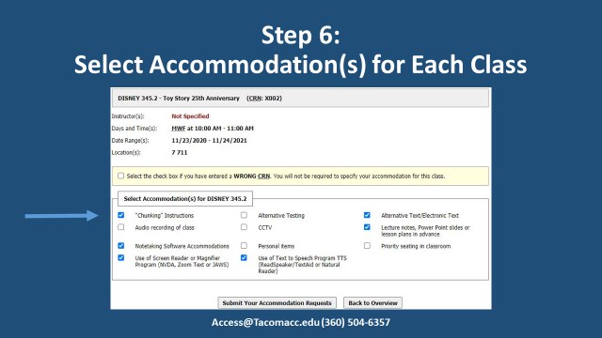
Now select accommodations for each class. Accommodations that you have been approved for will be listed below the class name. Check the box or boxes to customize accommodations per-class. You do not have to select all accommodations. Customize your request per class. Afterwards click the “Submit Your Accommodation Requests” when finished.
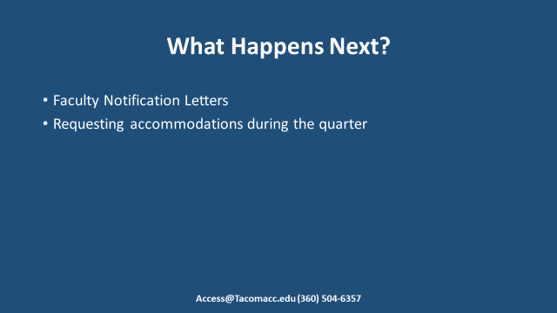
What happens next? Access Services staff will review your submitted Accommodation Request. Faculty Notification Letters will be sent to Faculty and yourself via email a week before classes start. NOTE: If you are requesting accommodations during the quarter it will typically take 3-7 business days before your Notification Letter is sent out.

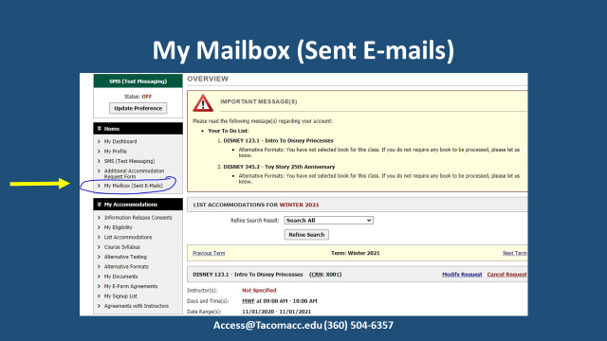
You can find your Faculty Notification Letter under My Mailbox (Sent E-mail) tab.

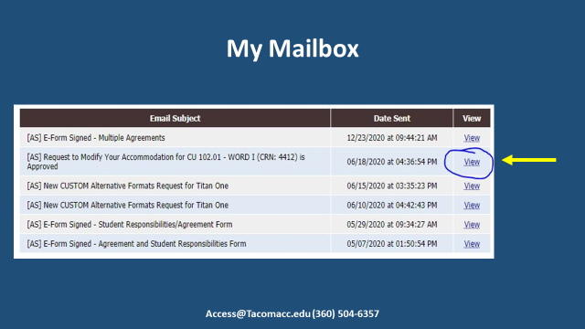
All Faculty Notification Letters can be found by selecting the View tab.
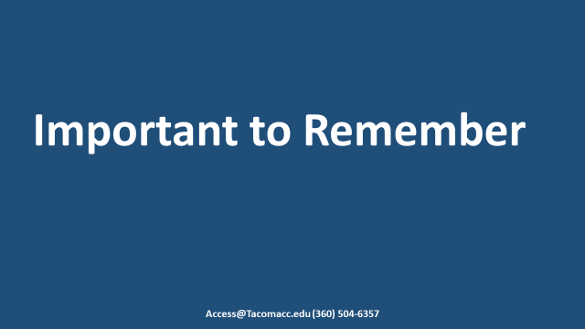
Wait-listed classes and classes in which an instructor has not yet been assigned will not show up in AIM. Let Access Services staff know if your class isn't showing up in AIM. Staff are able to add the classes manually. You will need to request your accommodations every quarter through your AIM account. PLEASE book mark this site and set a reminder for yourself to renew your accommodations EVERY quarter that you want to use them! If you change classes during the quarter, remember to log into AIM to make new request for the current classes.

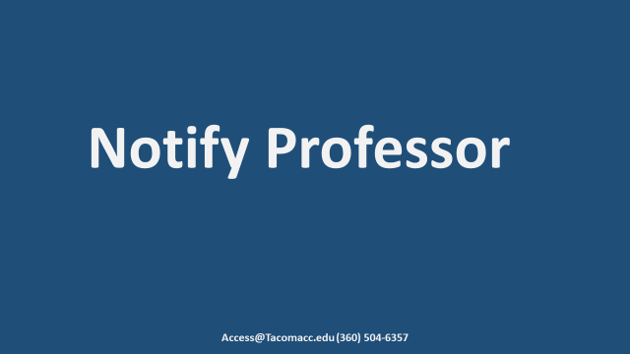
You are encourage to reach out to your Professors each quarter by email or Canvas message. Suggest that you set up a short one on one phone call or zoom meeting with them to review your list of Approved Accommodations which is sent through Access Services. Students who do that typically find that their communication for the rest of the quarter regarding their Accommodations will go a lot more smoothly.

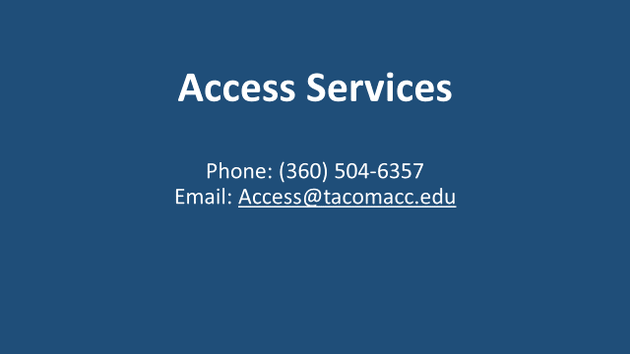
If you have any questions or concerns during the process, please contact Access@tacomacc.edu or (360) 504-6357. Thank you for joining the tutorial on how to request your Approved Academic Accommodations by quarter.

