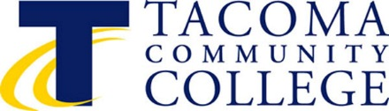

TACOMA COMMUNITY COLLEGE

BOARD OF TRUSTEES

6501 South 19th Street SPECIAL MEETING
Tacoma, WA 98466 Wednesday, November 14, 2018
3:00-4:00 p.m.
Building 12, Room 120

AGENDA

I. CALL TO ORDER James Curtis

II. STRATEGIC PLAN WORKSHOP CampusWorks

III. ADJOURNMENT James Curtis

